## **Module 3 Activity 5: Data Access**

Saurabh Kale

IFT 458/554: Middleware Programming & Database Security

Dinesh Sthapit

Sep 24th, 2023

**Reusable components to create composite components:-1**

**Utility.js-**

const generateRandomNumber = function (minimum, maximum){

    return Math.floor(Math.random() * (maximum-minimum))+minimum;

}

console.log(generateRandomNumber(10,100))

**Output-**

**generateRandomNumber used in index.js-**

**index.js-**

import * as Game from './utility.js'

console.log(Game.generateRandomNumber(10,100))

**Screenshot-**

**Running Both files-**

**Index.js-**

import * as Game from './utility.js'

console.log(`from index ${Game.generateRandomNumber(10,100)}`)

**utility.js-**

export const generateRandomNumber = function (minimum, maximum){

    return Math.floor(Math.random() * (maximum-minimum))+minimum;

}

console.log(`from Utility ${generateRandomNumber(10,100)}`);

**Output Screenshot-**

**Using Importing External Modules (third-party modules) -**

**Data Formats and Data Exchange-**

**Asynchronous block code-**

**Content Negotiation-**

**Could not satisfy request accept header-**

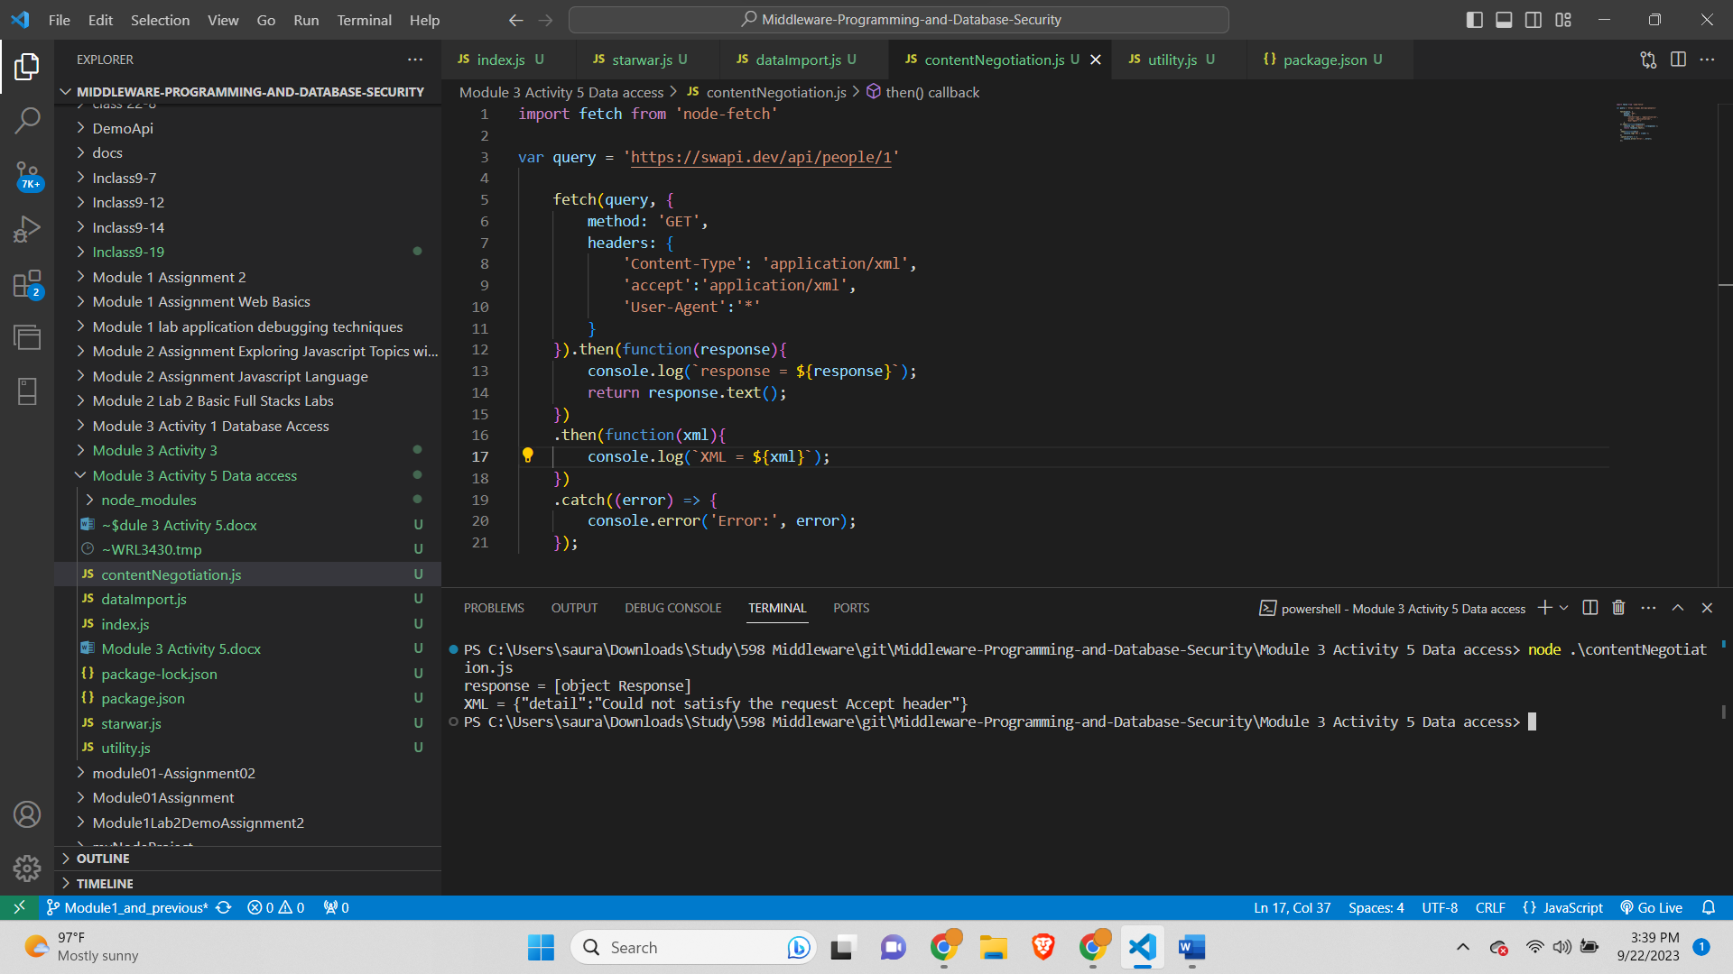

**Accepting json format-**

